

This system works differently to

the traditional appointments model, so it helps to think differently about how you use the system.

The following tips will help you get the best out of this new system. If you don’t need to be seen quickly think about the best day to make your call, and the most convenient day for you to attend or be called back.

If you have any particular

time constraints that day please

make sure you let the receptionist know and we will try our best to accommodate your wishes.

***We welcome feedback on the new system. We will conduct patient surveys over the next few weeks and keep you informed.***

Bampton Medical Practice

*Thousands of patients are already enjoying this service all around the country.Thousands of* patients are already enjoying this service all around the country.

***This is what they say:***

“I don’t worry about getting appointments in advance now – I can wait and call when I need to” **Female, aged 76**

“Trying to get through before taking the kids to school was a nightmare. Now you can get through anytime and get sorted the same day” **Mother, aged 39**

“This new system means you don’t have to take time off work to get an appointment because you know you will be seen if you need to be”. **Patient, aged 55**

“I always get an excellent service now from my practice. I get a call back from my own doctor at a time that suits me – I can’t fault the new system at all!” **Female, aged 38**

Bampton Surgery

Landells

Bampton

Oxfordshire

OX 18 2LJ.

Tel: 01993 850257

Bampton Medical Practice

Our appointment system is

changing

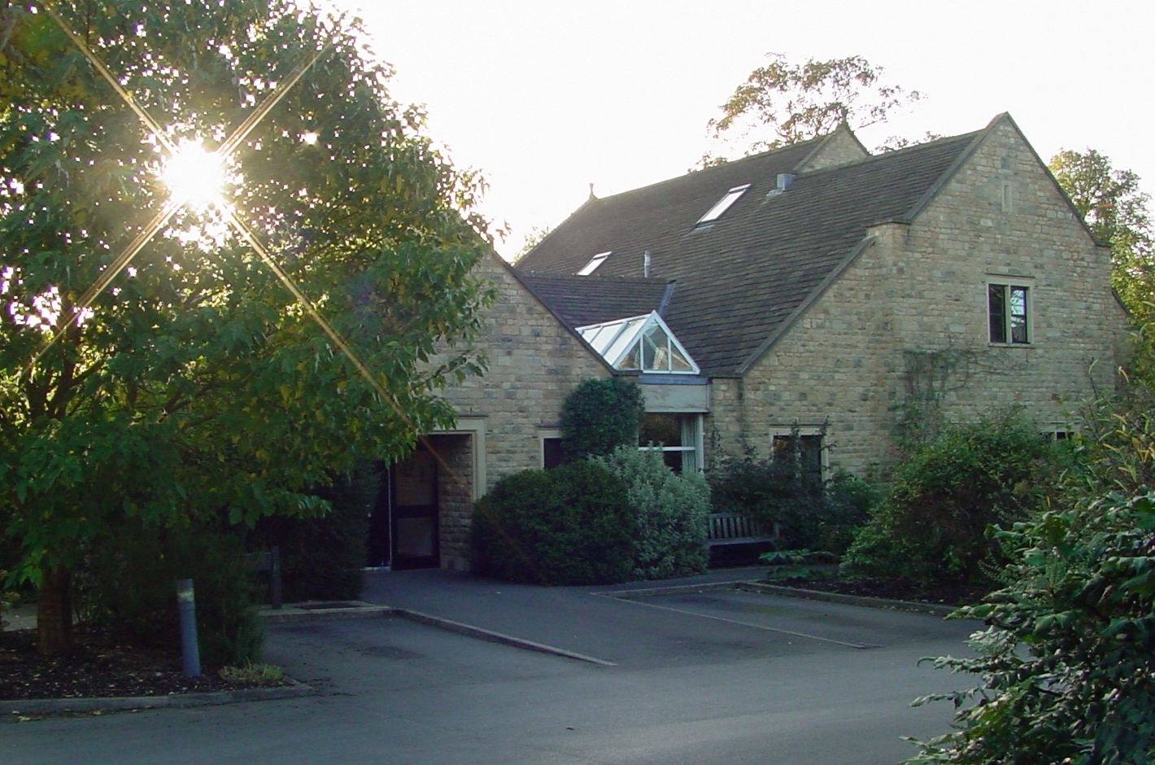

PLACE PHOTO HERE,

OTHERWISE DELETE BOX

From 9th April 2014

***What will the receptionist ask?***

“How can I help you?” The receptionist will take your telephone contact details. They may ask who your preferred doctor is and arrange for them to call you back. If your preferred doctor is not in that day you will be given the choice of waiting until they are next available or speaking to someone else.

You may also ask to see the practice nurse as normal.

***What happens when the doctor calls?***

The doctor will discuss the problem with you and work out what to do. You may only need advice, a prescription, or you may need to come in. The doctor will offer you an appointment the same day or a later day if you wish.

***What if I am at work?***

Employers are normally delighted that you can save time going to the surgery. Ask for a quiet spot to take the doctor’s call. If timing is an issue, please tell the receptionist

***Can they phone my mobile?***

Yes, the receptionist will check that they have the correct number when you call, mobile or landline.

***Can I call any time?***

Yes, the service is exactly the same during normal working hours. There is often a rush at the start of the day, so you may find a quicker response later.

If your request is not directly for a doctor, e.g. repeat prescription, please call after mid-morning when the lines are quieter.

...... and decided we had to change.

In order to improve patients experience of making an appointment with a doctor we are introducing a new system in the practice.

By adopting a few simple changes we want to improve our service.

This will mean:

* Reducing the wait to see the doctor
* Making it easier to get through on the phone
* Avoiding wasted time coming into the surgery when you don’t need to.

*We listened to what you had to say about seeing the doctor in our patient surveys over the last couple of years and although the results weren’t bad we felt that we could do better.*

**1. Phone the surgery**

Reception will ask for the most appropriate telephone number and the best time for the doctor to call you back.

*You may ask for a named doctor.*

*Providing they are working that day you will be given an appointment.*

**2. The doctor calls you back**

***When?*** *Usually within an hour.*

*You may request a preferred time*. **Please be there to answer the call**.

**3. You are seen as needed**

***When?*** *There is no need to book in advance. 9 out of 10 patients choose to come on the same day.*

You will have direct contact with a doctor sooner.

**

**